**JUnit Testing Exercises**

**Exercise 1:** Setting Up Junit

OUTPUT:

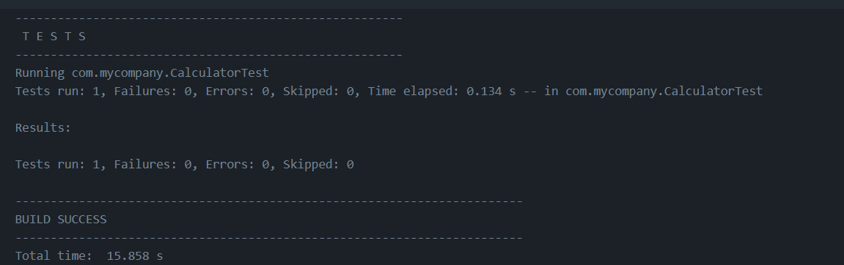

**Exercise 3:** Assertions in Junit

OUTPUT:

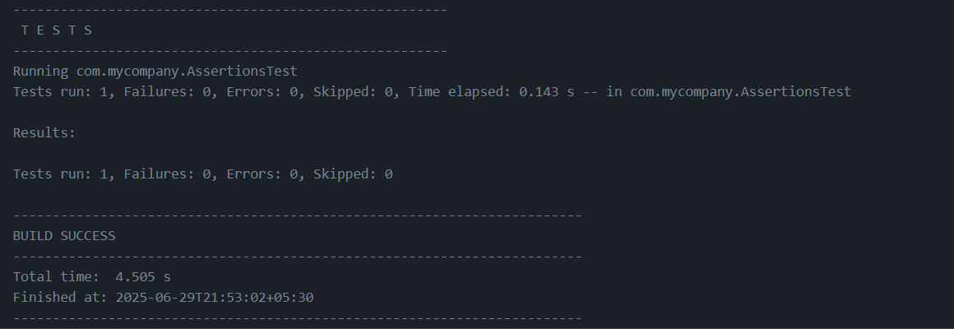

**Exercise 4:** Arrange-Act-Assert (AAA) Pattern, Test Fixtures, Setup and Teardown Methods in Junit

OUTPUT:

